Rowantree Primary School

Newsletter September 2026

As we storm through September, I wanted to write out to you again with some updates in this busy term.

A huge thank you also goes to all our families for the effort you have made with school uniform. It is wonderful to see our children looking so smart, proud and ready for learning each day. Please note gym kit should only be worn on gym days. The gym days are highlighted to yourselves through Seesaw.

ParentPortal – Please Sign Up
We would also like to remind all parents and carers to ensure they are registered for ParentPortal. The Portal provides quick and convenient access to a range of important school information and services, including:

- School reports
- Attendance information/logging absence
- Clothing grant applications
- School menus
- School holiday dates
- Free school meals applications

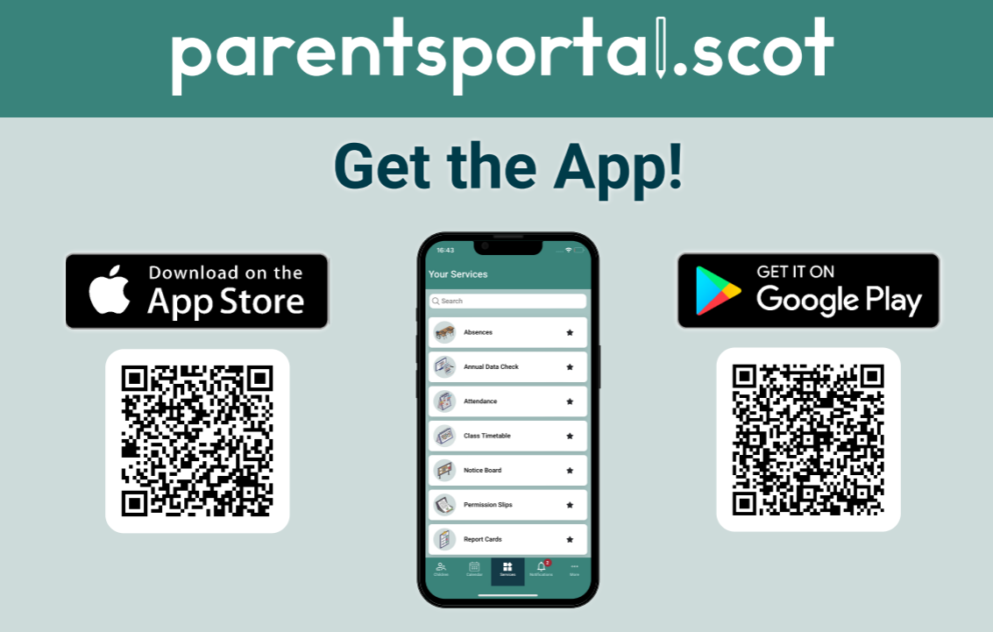

Celebrating Wider Achievements
We are incredibly proud of our young people and all that they achieve in school, but we also know that many fantastic achievements happen beyond the school day. Whether it’s success in sport, music, dance, clubs, community activities, or a personal milestone, we would love to hear about it and celebrate with them.
Please use the link provided to share your child’s wider achievements with us.

https://forms.office.com/e/0rNEJSB91A

Parent Council
We are delighted to welcome Leanne Ward as Chairperson and Jodi White as Secretary, following their successful appointment at our recent Parent Council AGM.
We would also like to say a huge thank you to our outgoing Chair, Kirsty Myles, along with Aggie Hunter, Sam Low, Linda Foy and Annie Wallace, who will be moving on, for all their hard work, time and commitment. We are always keen to welcome more parents to our meetings, and being involved does not mean you need to take on a formal role—it is a valuable opportunity to be part of the school community, share your views and get involved.
Our next Parent Council meeting will take place on 3rd November at 2pm, and all parents are very welcome to attend.

Car Park
We would also like to remind everyone that the school car park is for staff and Blue Badge holders only. Please do not park behind other vehicles or block cars in, as this can cause considerable difficulties for staff who need to leave the school during or at the end of the day. We appreciate your cooperation in helping us keep the car park safe and accessible for those who need to use it.

Below are important dates for your diary:

Open Doors | 2nd October 2026 2:15pm
School closes for Oct break | 9th October 2026
School reopens | Monday 26th October
Halloween Dress Up | Friday 30th October
Parent Contact nights | Monday 9th & Wednesday 11th Nov

Attendance
I would like to kindly remind parents and carers that we are receiving an increasing number of calls requesting that children are collected early from school. We completely appreciate that appointments and unavoidable circumstances do arise; however, frequent early collections place additional pressure on our busy school office and can disrupt children’s learning. We are also receiving numerous calls asking the office to pass on messages to children regarding changes to arrangements at the end of the school day. While we will always help where we can, the volume of these requests creates further disruption for both office staff and classes. Please ensure that your child is clear about their arrangements for the day before they arrive at school wherever possible. We really appreciate your understanding and support in helping the school day run smoothly for everyone.
Attendance will continue to be a key priority for us this session, as regular attendance plays an important role in supporting your child’s learning and progress. If your child is unable to attend school due to illness, please contact the school office on 01382 307870 to let us know. If we have not received notification regarding your child’s absence, we will contact you by text message or telephone.
Our current attendance statistics will also be displayed in the reception area, helping us to keep our school community informed.
Thank you for your continued support,
Yours sincerely,

T Ross
Headteacher

